QUDIT MS Teams Pilot

Requirements

Background
At present QUDIT Community of Practice members need to manually switch tenants to access information contained in their community Team channels. The Community forums are intended as an interactive collaboration space to engage in virtual dialogue and as a centralised repository for Community resources. The need to switch tenants has created barriers and presented several inefficiencies impacting the practical use of the intended sector collaboration space. These include:
- When outside the tenant, users are not alerted to notifications from the Community Teams channel.
- Meeting participation links cannot be accessed when outside the tenant.
- Switching between tenants can be problematic for members using VOIP through MS Teams.
- It is difficult to encourage cross-sector collaboration when access is impeded.

Objectives
The objective of the pilot is to setup MS Teams conforming with a set standard so that members can benefit from an interactive collaboration space across different tenants to stay connected and engage in virtual dialogue.

Understanding Teams Channels

What channels are available in Microsoft Teams?
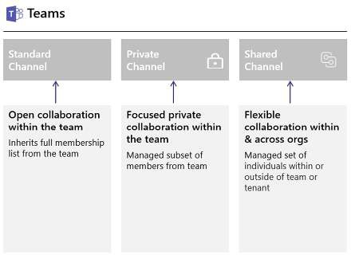

What is a shared channel in Microsoft Teams?

A Teams shared channel is a third new Teams channel type. It builds upon the existing standard and private channel types to extend the organisational boundary, allowing users from multiple organisations to collaborate in a shared space without having to switch tenants as they would with a standard or private channel.

Enabling Shared Channels

To enable Shared Channels, administrators need to log into Azure AD and turn them on separately for outbound (shared channels created by other organizations are joinable) and inbound (external collaborators can join your organization’s shared channels).
By default, both options are turned off.

Minimum requirements

To allow staff from institutions to be added as guests in MS Teams shared channels, guests will need to have, at a minimum, their outbound settings enabled in B2B direct connect to be able to connect with your team/channel. Otherwise a guest cannot be invited.

Options for Enabling Shared Channels
There are two options available to allow access to shared channels for your institution:

(Option A) Adjust the global policy to allow B2B Direct Connect

This option allows for the adjustment of the global policy to allow B2B Direct Connect settings for all users without restriction or limitation.
Both the outbound and Inbound settings will need to be adjusted:

    - Inbound settings – guests that can be added to my tenant.
    - Outbound – people from my tenant that could be added as guests to other tenants.

An example of both inbound and outbound settings is shown in the images below:
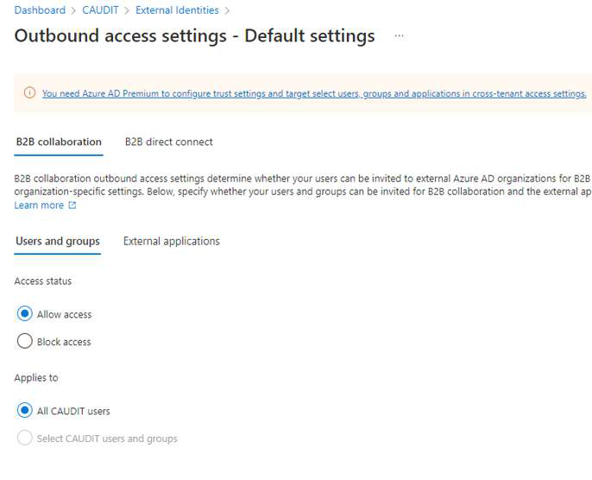

NB: re ‘outbound settings’:
As a minimum, to allow access to shared channels, it is important to allow ‘external users and groups’ and ‘all applications’ for the outbound settings (‘Outbound’ – people from my tenant that can be added as guests to other tenants). If required, there is the option to just choose specific groups or individual users that can access shared channels.

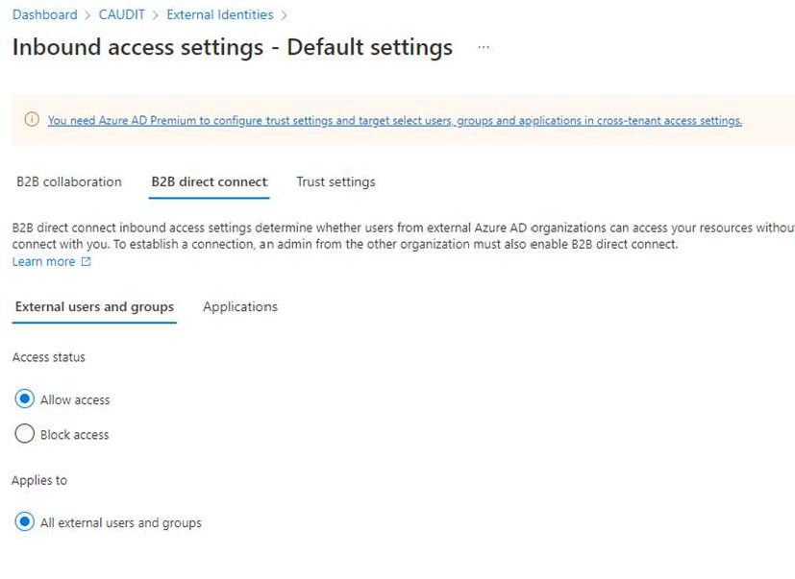

(Option B) Keep defaults blocked and make exceptions

This option provides for keeping the defaults blocked and to make exceptions for specific tenants (in this case it should be all the QUDIT member organisations i.e. JCU CQUni, UniSC, QUT, UQ, Griffith, UniSQ, SCU, Bond, ACU, CSIRO, Aims and QIMRBerghofer.)
Go to ‘organisational settings’ as shown in the image below:

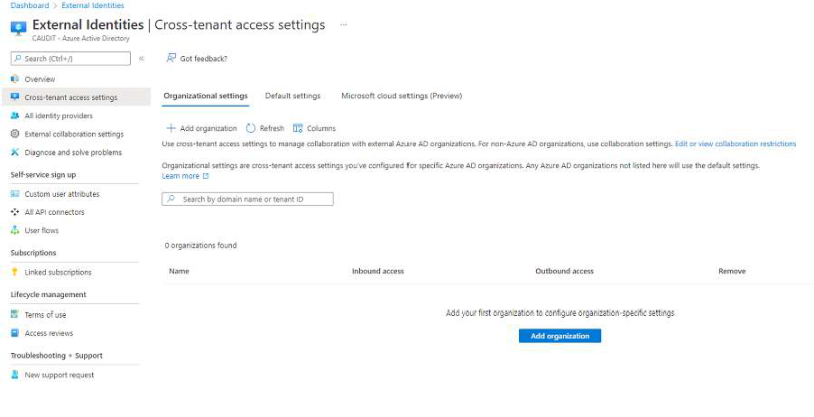
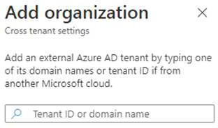

Security and Governance

Now that external users can be members of shared channels with their native tenant credentials, questions often arise about the governance of content they have access to. It is important to note that any policies that govern access to the content in a Teams shared channel, such as retention policies or DLP policies, are the policies of the host tenant. The host teams and Microsoft 365 policies take precedence over any policies that might be in use for the external user in their tenant.
For noting:

- MS Teams administrators cannot access an institution’s GAL. In order to invite a guest, the administrator will need to enter the full email address.
- Privacy/profile information is not governed by the guest Institution but rather by the organisation you are connecting to (similar to Yammer)
- DLP/retention policy does not apply to external channels
- Members to trust each institution’s MFA
- Only guests who are invited to join can gain access to the shared channel
- Channels cannot be discovered by users who have not been invited
- Guests cannot add other guests
- Only team owners can invite someone to the shared channel from the host domain

It is worth noting that no major issues arose from the CAUDIT Proof of Concept undertaken Q3 of 2022 relating to security and governance policies.

Technical information that guest organisations need from other organisations

- Tenant ID/Domain, for example:
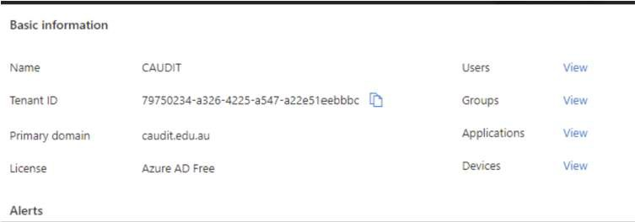

- Group ID
  - Host Team - groupId=192f98e6-4496-4d98-aa8f-72f6acee570f
    - https://docs.microsoft.com/en-us/microsoftteams/platform/tabs/how- to/access-teams-context?tabs=teamsjs-v2#retrieve-context-in-microsoft- teams-connect-shared-channels

Testing

Individuals from all QUDIT members organisations have already been given access to the QUDIT MS Teams space hosted by SCU. Once members have completed their university MS Teams setup we can do testing on the channel. After you have made the necessary updates in Azure AD, please email andre.dreyer@qut.edu.au and I will notify TAC members that your university’s space has been set up and a few tests can be run between the universities.

Success Metrics

      - Ensuring that notifications are received.
      - Functionality during online meetings including the ability to issue calendar invites within the channel, record the session, be allocated as an alternate host and access chat.
      - What there is of other guests’ information/details.
      - Ability to create and share documents within the channel.
      - Ease of access to all information included in the top menu of the shared channel.
      - Any lag issues in accessing information.
      - The chat function with other community members.
      - Managing onboarding/offboarding of staff.

Assumptions and Constraints
Members need to liaise with their cybersecurity representatives regarding the security settings for MS Teams.
The QUDIT CIOs endorsed the project and correspondence has been sent to the QUDIT board regarding progressing the initiative. You are welcome to confer with your CIO in this regard.

Closure
On successful completion of the pilot, we will request approval from the QUDIT board to operationalise the configuration for the QUDIT universities.

